Design Sketch
How your design will slow thermal energy transfers.

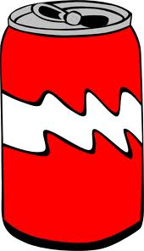

Thermal Energy Transfer
How thermal energy was transferred to the can.

Name: Hour:
Improvements - Rough Draft

Think about how you would improve your design. Take ideas that you have from your testing, along with what you learned by observing others, to write a paragraph explaining at least two changes you would make and the reasoning behind them. This should be written in paragraph format that includes many details.

Data Chart

Time | 0 min. | 5 min. | 10 min. | 15 min. | 20 min. | 25 min. | 30 min.
Experimental Can Temperature (°C)
Control Can
Temperature (°C)

Change in Temperature

Experimental Can: _______ °C

Control Can: _______ °C

Graph

Cold Can Challenge
Display Checklist

- Title and names of all group members

- Design Sketch
  - Include all material used and why you used them to slow thermal energy transfers
  - Include words such as insulator, conductor, absorb, and reflect

- Data Chart and Graph
  - Data recorded
  - Title for graph
  - X and Y axis labeled
  - Appropriate scale for each axis
  - Line graph for experimental can and control can

- Thermal Energy Transfer - Explanation and drawing of how the thermal energy was transferred to the can
  - Include radiation, conduction, and convection in your explanation
  - Include areas of the box that transferred heat through radiation, conduction, or convection

- Improvements - Changes for the future to improve your design – added after presentations

Improvements by _________________________

________________________________________________________________________________________________________________________________________________________________________________________________________________________________________________________________________________________________________________________________________________________________________________________________________________________________________________________________________________________________________________________
________________________________________________________________________________________________________________________________________________

